STEP-BY-STEP MANUAL

Mobile Game Development Project
ROCK FALL
3D Game Space Shooter

Members:

Gano Spencer Chumilang
Ver Velasco Raquepo
Jan Ellisson Sebastian

BSIT - 4A

Submitted to:

Sir Jason Nacorda

January 8, 2026

Table of Contents

Project Overview - - - - - - - - - - - - - - - - - - - - - - - - - - - - - - - - - - - - - 1
Tools & Technology - - - - - - - - - - - - - - - - - - - - - - - - - - - - - - - - - - - - 2
Installation & Setup - - - - - - - - - - - - - - - - - - - - - - - - - - - - - - - - - - - - 3
Architecture & Code Walkthrough - - - - - - - - - - - - - - - - - - - - - - - - - - - - - 4
Game Design & UI - - - - - - - - - - - - - - - - - - - - - - - - - - - - - - - - - - - - 5
Art & Sound Pipeline - - - - - - - - - - - - - - - - - - - - - - - - - - - - - - - - - - - - 6
Deployment & Release Notes – - - - - - - - - - - - - - - - - - - - - - - - - - - - - - - 7
Future Work - - - - - - - - - - - - - - - - - - - - - - - - - - - - - - - - - - - - - - - - 8
Appendices - - - - - - - - - - - - - - - - - - - - - - - - - - - - - - - - - - - - - - - - 9

- Project Overview

Rockfall is a 3D space survival game built in Unity. Players pilot a ship to protect a space station by evading and shooting down incoming asteroids. The goal is to survive for as long as possible, with a scoring system that rewards both longevity and defensive prowess.

Tools & Technology

2.1 Game Engine
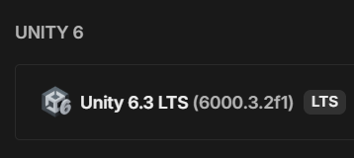
- Unity Version: Unity 2025. 3 LTS
Why this matters: Unity provides strong 3D support, mobile optimization, and an easy Android build system.

2.2 Programming Language
- C# – used for all gameplay scripts and logic.

2.3 Development Tools
- Unity Hub – project management
- Visual Studio – code editor
- Android SDK & JDK – required for Android builds

2.4 Assets & Resources
- 3D models: Free low-poly spaceship and asteroids
- Audio: Free sound effects for shooting and explosions
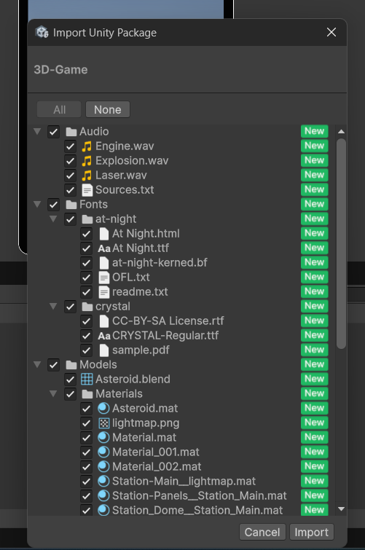
- Asset sources:
  - OpenGameArt.org

3. Installation & Setup (Step-by-Step)

3.1 Pre-requisites
- Install Unity Hub
- Install Unity 2023.3 LTS
  - Include Android Build Support
  - Android SDK & NDK
  - OpenJDK

3.2 Opening the Project
- Download or unzip the project folder
- Open Unity Hub
- Click Open Project
- Select the RockFall project folder

3.3 Running the Game in Editor
- Open the MainMenu scene
- Click the Play button
- Use keyboard/mouse for testing

3.4 Building APK for Android
- Go to File → Build Settings
- Select Android
- Click Switch Platform
- Click Build and Run
- Ensure USB debugging is enabled on device

4. Architecture & Code Walkthrough

4.1 High-Level Architecture
The game follows a simple component-based architecture:
- Game Manager – controls game state
- Player Controller – movement and shooting
- Asteroid Spawner – spawns falling asteroids
- UI Manager – score and health display
- Audio Manager – sound effects

4.2 Folder Structure

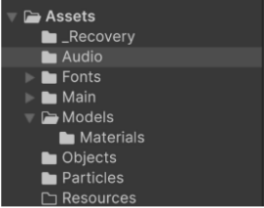

4.3 Key Scripts
- GameManager.cs – handles game start, game over, restart
- PlayerController.cs – spaceship movement and firing
- AsteroidSpawner.cs – creates falling asteroids
- ScoreManager.cs – tracks player score

4.4 Data Storage
- Player score is stored using PlayerPrefabs
- No cloud or online storage used

5. Game Design & UI

5.1 Core Mechanics
- Move spaceship left/right
- Tap fire button to shoot
- Destroy asteroids to gain score
- Game ends when player collides with asteroid

5.2 UI Flow
Main Menu → Gameplay → Game Over → Restart / Exit

5.3 Accessibility
- Large UI buttons
- Simple controls
- Clear contrast between objects

5.4 Asset Attribution
All assets used are free and licensed for educational use.

6. Art & Sound Pipeline

6.1 Asset Optimization
- Low-poly 3D models
- Compressed textures
- Short audio clips

6.2 Naming Conventions
- player_ship.fbx
- asteroid_large.fbx
- laser_shot.wav

6.3 Adding New Assets
- Import asset into Assets folder
- Assign material and scale
- Attach to prefab

7. Deployment & Release Notes

7.1 Deployment
- Built as Android APK
- Ready for Play Store upload

7.2 Release Notes (v1.0)
- Basic space shooter gameplay
- Scoring system
- Game over screen
- Mobile controls

8. Future Work / Improvements
- Power-ups
- Boss enemies
- Leaderboard
- Soundtrack music
- Difficulty selection

9. Appendices
- https://github.com/ShalamanShalaman/ShalamanShalaman-PEBSIT004_Rockfall3D_ChumilangGanoD_RaquepoVerV_SebastianEllissonG.git

